1. I need a landing page for a travel company dealing with holidays and tours.

----------------------------------------------------------------------------------------------------------------------

Here’s an idea for the layout:

- \*\*Welcome Section\*\*: A big, bold image of a top destination with a short and sweet intro.

- \*\*Tour Highlights\*\*: A few key tours or holiday packages with cool descriptions and prices.

- \*\*Traveler Reviews\*\*: Real stories or quotes from people who’ve had a great time.

- \*\*Why Travel with Us?\*\*: A little section about what makes your company the best choice for holiday planning.

- \*\*Footer\*\*: Contact info and links to your social media so people can follow and stay in touch.

----------------------------------------------------------------------------------------------------------------------

2. I'm looking at a page which will feature travel packages in India and Maldives mainly with a general coverage of other

worldwide locations too. The name of the company will be High Time Holidays. Will need a contact box / chat box if possible

on top. Rest as you mentioned.

----------------------------------------------------------------------------------------------------------------------

India and Maldives as the focus, worldwide options, plus a contact/chat box on top.

----------------------------------------------------------------------------------------------------------------------

1. Travel and tourism aimed at selling holiday packages

2. You know better, I think

3. Sell fully inclusive holiday packages for Maldives, Kerala (in India) and other locations

4. Blue, green should be nice

5.

Email : hightimeholidays@gmail.com

Address : High Time Holidays, V Towers, KK Road, Kaloor, Kochi, India

----------------------------------------------------------------------------------------------------------------------

Designing the layout for the project

I will focus on creating a landing page design for a travel company named "High Time Holidays." The focus is on selling

fully inclusive holiday packages to India (Kerala) and the Maldives, with additional worldwide options.

Layout Requirements:

1. Contact/Chat Box: Place at the top of the page for inquiries.

Name

No. of Adults and Child

Email

Phone

Describe your holiday plan

2. Welcome Section:

• Include a large, bold image of a top destination (preferably from India or the Maldives).

• Add a short, engaging introduction about the company.

3. Tour Highlights Section:

• Feature a selection of key tours/holiday packages with enticing descriptions and prices.

4. Traveler Reviews Section:

• Display quotes or stories from satisfied customers.

5. Why Travel with Us Section:

• Briefly explain what sets High Time Holidays apart in the travel industry.

6. Footer:

• Include the company’s contact information:

• Email: hightimeholidays@gmail.com

• Address: High Time Holidays, V Towers, KK Road, Kaloor, Kochi, India

• Add links to social media platforms for engagement.

Design Aesthetics:

• Use a color palette featuring blue and green to evoke a travel vibe.

Make the design user-friendly and visually appealing to attract potential travelers.

----------------------------------------------------------------------------------------------------------------------

New Requirements

Please add some pics of Kerala too.

Pics added to carousel

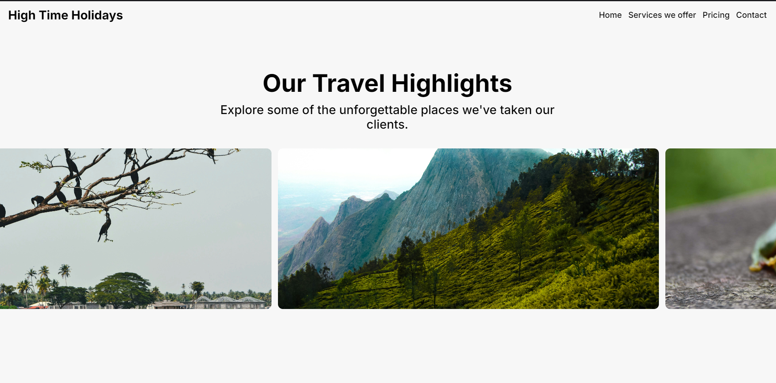

\*All photos are from unsplah.com and they dont have copyright\*

Our services and our pricing area looks a bit plain and dull so if you can add some colour to the background

The spaces between travel packages and next sections is empty so if you can add something there.

Here is the pics of all the sections, fixed if any was empty now if filled

Add links to the home section

Links added to the navbar